ISPPD Workshop #2 Evaluating Vaccine Impact using Time Series Data

Daniel M. Weinberger ([daniel.weinberger@yale.edu](mailto:daniel.weinberger@yale.edu)) and Kayoko Shioda ([kayoko.shioda@yale.edu](mailto:kayoko.shioda@yale.edu))

Sunday, April 15, 2018

## Set up

First, download "Brazil_acp.csv" and save it in your folder.

Then, run the following section to import the dataset.

# Set working directory  
setwd("C:/Users/dmw63/Dropbox (Personal)/ISPPD workshop") # Please update this line   
  
# Import the data in a .csv file  
d <- read.csv("Brazil_acp.csv")

Let's explore the dataset a little bit...

# Explore the dataset  
names(d)

## [1] "age_group" "date" "J12_18"   
## [4] "A10_B99_nopneumo" "A17" "A18"   
## [7] "A19" "A39" "A41"   
## [10] "B20_24" "B34" "B96"   
## [13] "B97" "B99" "C00_D48"   
## [16] "D50_89" "E00_99" "E10_14"   
## [19] "E40_46" "G00_99_SY" "H00_99_SY"   
## [22] "I00_99" "I60_64" "cJ20_J22"   
## [25] "K00_99" "K35" "K80"   
## [28] "L00_99" "M00_99" "N00_99"   
## [31] "N39" "P00_99" "P05_07"   
## [34] "Q00_99" "S00_T99" "U00_99"   
## [37] "V00_Y99" "Z00_99" "ACH_NOJ"

head(d)

## age_group date J12_18 A10_B99_nopneumo A17 A18 A19 A39 A41 B20_24  
## 1 80+ 1/1/2004 3192 1357 NA NA NA NA 249 NA  
## 2 80+ 2/1/2004 3691 1389 NA NA NA NA 275 NA  
## 3 80+ 3/1/2004 6131 1604 NA NA NA NA 305 NA  
## 4 80+ 4/1/2004 5044 1377 NA NA NA NA 258 NA  
## 5 80+ 5/1/2004 4694 1385 NA NA NA NA 260 NA  
## 6 80+ 6/1/2004 4986 1449 NA NA NA NA 295 NA  
## B34 B96 B97 B99 C00_D48 D50_89 E00_99 E10_14 E40_46 G00_99_SY H00_99_SY  
## 1 NA NA NA NA 1715 481 2349 866 800 696 271  
## 2 NA NA NA NA 1618 406 2221 770 780 668 280  
## 3 NA NA NA NA 2129 490 2393 828 805 672 374  
## 4 NA NA NA NA 1819 426 2123 727 767 624 279  
## 5 NA NA NA NA 1943 420 2178 796 796 754 355  
## 6 NA NA NA NA 1821 404 2131 773 745 729 330  
## I00_99 I60_64 cJ20_J22 K00_99 K35 K80 L00_99 M00_99 N00_99 N39 P00_99  
## 1 12168 2683 0 2930 9 110 522 844 2070 227 1  
## 2 11274 2511 0 2779 21 122 515 757 1896 220 1  
## 3 12445 2592 1 3161 17 150 648 899 2224 229 3  
## 4 11500 2594 2 2762 16 110 525 792 1915 205 0  
## 5 11872 2731 2 2994 15 114 539 899 2021 232 0  
## 6 12580 2764 3 2793 20 139 535 909 1898 234 1  
## P05_07 Q00_99 S00_T99 U00_99 V00_Y99 Z00_99 ACH_NOJ  
## 1 NA 96 2016 NA NA 190 30727  
## 2 NA 69 1907 NA NA 157 29844  
## 3 NA 79 2076 NA NA 215 33020  
## 4 NA 74 2020 NA NA 210 28916  
## 5 NA 83 2402 NA NA 177 30341  
## 6 NA 71 2369 NA NA 184 30565

table(d$age_group)

##   
## <1 80+   
## 120 120

Let's take a look at a date variable. How does it look like? Is it in a right format?

class(d$date) # "factor" --> Need to change it to "date"

## [1] "factor"

head(d$date)

## [1] 1/1/2004 2/1/2004 3/1/2004 4/1/2004 5/1/2004 6/1/2004  
## 120 Levels: 1/1/2004 1/1/2005 1/1/2006 1/1/2007 1/1/2008 ... 9/1/2013

# Change the type of the date variable so that R can recognize it as a date variable  
d$date <- as.Date(d$date,format="%m/%d/%Y")  
class(d$date) # Now it's changed to "Date"

## [1] "Date"

head(d$date)

## [1] "2004-01-01" "2004-02-01" "2004-03-01" "2004-04-01" "2004-05-01"  
## [6] "2004-06-01"

Next, let's load packages that we will be using in the following sections.

# Load libraries  
library(MASS)  
library(lubridate)

## Warning: package 'lubridate' was built under R version 3.3.3

##   
## Attaching package: 'lubridate'

## The following object is masked from 'package:base':  
##   
## date

# If you do not have these packages installed, please run the following line.  
# Replace "PackageName" with the name of the package you'd like to install.  
#install.packages("PackageName")

## Part 1. Visualize the Data

### Part 1-a. J12-18

Make a plot for the time series for all-cause pneumonia hospitalizations (ICD10 code: J12-18) among children <12 months of age.

Sort the dataset by date, and make the same plots for <12 mo and 80+ yo.

# Sort the dataset by date  
d <- d[order(d$date),]  
  
# <12 mo  
plot(J12_18 ~ date, data=d[d$age_group=="<1",],   
 type="l", bty="l", col="blue", lwd=2,   
 ylim=c(0,max(d$J12_18[d$age_group=="<1"])),  
 xlab="Months", ylab="Number of hospitalizations",   
 main="Monthly number of J12-18, <12 mo")  
 abline(v=as.Date("2010-01-01"), lty=2)

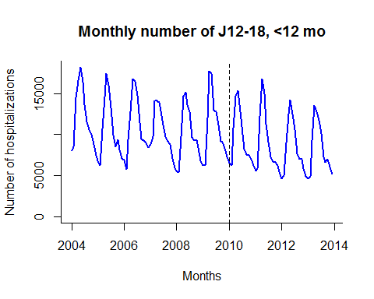

# 80+ yo  
plot(J12_18 ~ date, data=d[d$age_group=="80+",],   
 type="l", bty="l", col="darkgreen", lwd=2,  
 ylim=c(0,max(d$J12_18[d$age_group=="80+"])),  
 xlab="Months", ylab="Number of hospitalizations",   
 main="Monthly number of J12-18, 80+ yo")  
 abline(v=as.Date("2010-01-01"), lty=2)

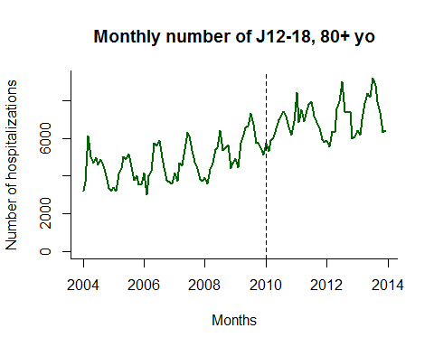

What kind of trend do you see in J12-18 for each age group?

### Part 1-b. ACJ_NOJ

Plot the time series for non-respiratory hospitalizations (i.e., ACH_NOJ) for <12 mo and 80+ yo. This variable will be used as an offset for regression models.

First, to make the following analyses easier, let's subset the datasets into two age groups (<12 mo and 80+ yo).

young <- d[d$age_group=="<1",]  
old <- d[d$age_group=="80+",]

Now let's make plots for ACH_NOJ.

# <12 mo  
plot(ACH_NOJ ~ date, data=young, bty="l", type="l",  
 ylim=c(0,max(old$ACH_NOJ)),  
 xlab="Months", ylab="Number of hospitalizations",  
 col="blue", main="ACH_NOJ, <1 yo")  
 abline(v=as.Date("2010-01-01"), lty=2)

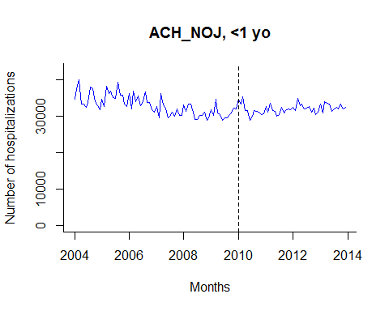

# 80+ yo  
# Version 1 (y axis from zero to the max. number of hospitalizations)  
plot(ACH_NOJ ~ date, data=old, bty="l", type="l",  
 ylim=c(0,max(old$ACH_NOJ)),  
 xlab="Months", ylab="Number of hospitalizations",   
 col="darkgreen", main="ACH_NOJ, 80+ yo")  
 abline(v=as.Date("2010-01-01"), lty=2)

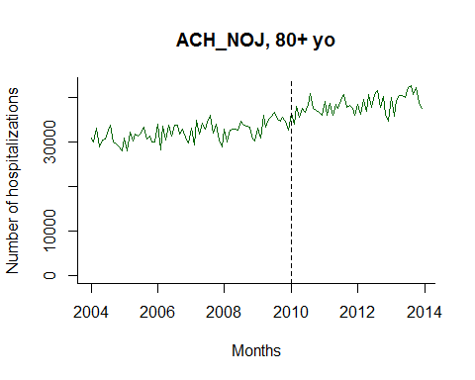

# Verson 2 (zoom in)  
plot(ACH_NOJ ~ date, data=old, bty="l", type="l",  
 xlab="Months", ylab="Number of hospitalizations",   
 col="darkgreen", main="ACH_NOJ, 80+ yo (zoom)")  
 abline(v=as.Date("2010-01-01"), lty=2)

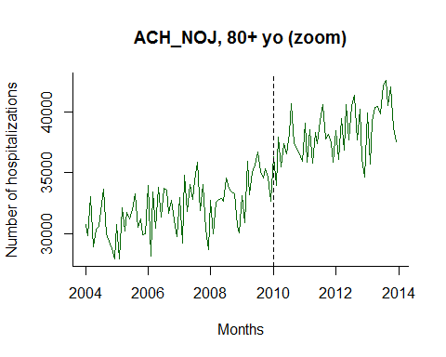

What kind of trend do you see in ACH_NOJ for each age group?

## Part 2. Negative Binomial Regression

First, we will fit a regession just to the **pre-vaccne** data and will extrapolate the trend to the post-vaccine period to estimate the **counterfactual**.

Because the outcome is a **COUNT** variable, it is most appropriate to use a log-linked Poisson or negative binomial regression, rather than linear regression.

Due to the over-dispersion present in the data, we will fit a negative binonimal regression.

### Part 2-a. Set up

In order to fit a model just to the pre-vaccine period, set the outcome (J12-18) to missing (NA) for the post vaccine period.

NOTE: PCV10 was introduced on Jan 1, 2010 in Brazil.

# Create a new variable J12_18_pre which is NA (missing) in the post-vaccine period.  
# <12 mo  
young$J12_18_pre <- young$J12_18  
young$J12_18_pre[which(young$date>="2010-01-01")] <- NA   
# 80+  
old$J12_18_pre <- old$J12_18  
old$J12_18_pre[which(old$date>="2010-01-01")] <- NA   
  
# Check if it was created as we want.  
#data.frame(young$date, young$J12_18, young$J12_18_pre)  
#data.frame(old$date, old$J12_18, old$J12_18_pre)

Next, let's create on offset term for negative binomial regression using ACH_NOJ (in a log scale).

# Create an offset term in a log scale--this is the denominator for the regression.  
young$log_offset <- log(young$ACH_NOJ)  
old$log_offset <- log(old$ACH_NOJ)

We will also create a time index variable to control for a long term linear trend.

# Create a time index variable (1, 2, 3, 4, ..., number of datapoints)  
young$time <- 1:nrow(young)  
old$time <- 1:nrow(old)  
young$month<-as.factor(month(young$date))  
old$month<-as.factor(month(old$date))

As the outcome J12-18 shows a clear seasonality, we will adjust for it in the regression model. We can do it in two ways: * Using monthly dummy variables (We will do this here) * Using harmonic terms (sine, cosine) ### Part 2-b. Fit a negative binomial model

Fit negative binomial models to the prevaccine data.

NB_yng_s1 <- glm.nb(J12_18_pre ~ time + month + offset(log_offset), data=young)  
NB_old_s1 <- glm.nb(J12_18_pre ~ time + month + offset(log_offset), data=old)

Exrapolate the trend to the post-vaccine period and generate the counterfactual for J12-18.

Pred_NB_yng_s1 <- predict(NB_yng_s1, newdata=young, type="response", se.fit=T)  
#Pred_NB_yng_s2 <- predict(NB_yng_s2, newdata=young, type="response", se.fit=T)  
Pred_NB_old_s1 <- predict(NB_old_s1, newdata=old, type="response", se.fit=T)  
#Pred_NB_old_s2 <- predict(NB_old_s2, newdata=old, type="response", se.fit=T)

Plot time series for observed J12-18 vs. counterfactual J12-18.

# <12 mo  
plot(Pred_NB_yng_s1$fit ~ young$date,  
 type="l",col="red", bty="l", lwd=2,  
 ylim=c(0,max(c(young$J12_18, Pred_NB_yng_s1$fit))),  
 ylab="Number of hospitalizations", xlab="Months",   
 main="Negative binomial model (<12 mo)")  
lines(J12_18 ~ date, data=young, col="black",lwd=2)  
abline(v=as.Date("2010-01-01"),col="darkgrey",lty=2, lwd=2)  
legend(x="bottomleft",legend=c("Observed","Monthly dummy","Harmonics"),  
 col=c("black","red","blue"),lty=c(1,1,1),bty="n")

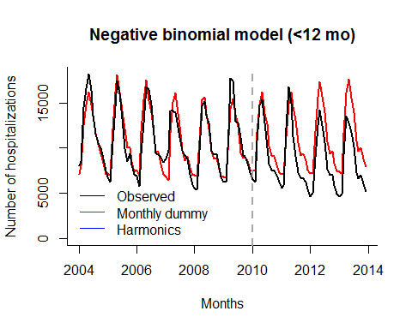

# 80+ mo  
plot(Pred_NB_old_s1$fit ~ old$date,  
 type="l",col="red", bty="l", lwd=2,  
 ylim=c(0,max(c(old$J12_18, Pred_NB_old_s1$fit))),  
 ylab="Number of hospitalizations", xlab="Months",   
 main="Negative binomial model (80+ yo)")  
lines(J12_18 ~ date, data=old, col="black",lwd=2)  
abline(v=as.Date("2010-01-01"),col="darkgrey",lty=2, lwd=2)  
legend(x="bottomleft",legend=c("Observed","Monthly dummy","Harmonics"),  
 col=c("black","red","blue"),lty=c(1,1,1),bty="n")

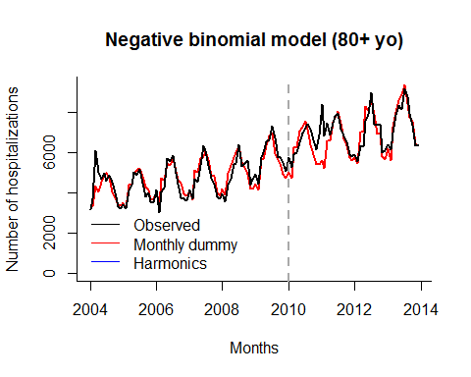

### Part 2-c. Rate ratios (RRs)

Calculate the rate ratios (RRs)

RR_NB_yng <- young$J12_18/Pred_NB_yng_s1$fit  
RR_NB_old <- old$J12_18/Pred_NB_old_s1$fit

Plot RRs by time.

# <12 mo  
plot(RR_NB_yng ~ young$date, type="l", bty="l", col="red",  
 main="RR for <12 mo", xlab="Months", ylab="Estimated RR", ylim=c(0.5,1.5))  
abline(h=1,col="darkgrey",lty=2)  
abline(v=as.Date("2010-01-01"),col="darkgrey",lty=2)

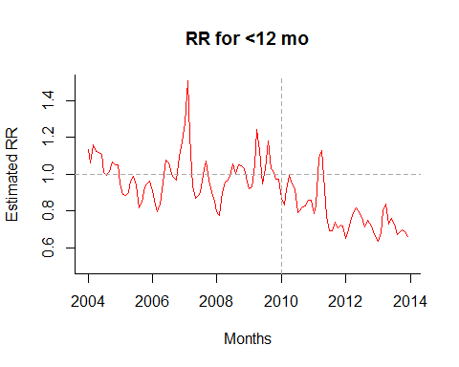

# 80+ yo  
plot(RR_NB_old ~ old$date, type="l", bty="l", col="red",  
 main="RR for 80+ years", xlab="Months", ylab="Estimated RR", ylim=c(0.5,1.5))  
abline(h=1,col="darkgrey",lty=2)  
abline(v=as.Date("2010-01-01"),col="darkgrey",lty=2)

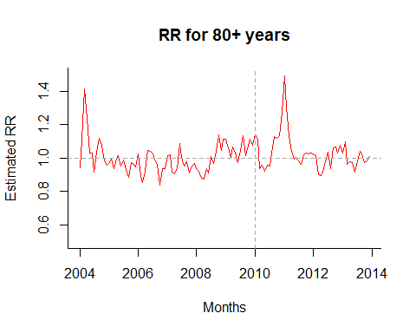

### Part 2-e. Leave-one-season-out analysis

As a sensitivity analysis, we can fit a series of negative binomial models by excluding one season at a time.

For example, the 1st model will be fit to the pre-vaccine data excluding the first year of the pre-vaccine period; the 2nd model will be fit to the pre-vaccine data excluding the second year...

There are 6 years of pre-vaccine data, so we will fit 6 models.

Let's start with the young age group.

# First, let's create an empty matrix to store results.  
lvso_yng <- matrix(NA, nrow=nrow(young), ncol=6)  
for (i in 1:6) {  
   
 # 1. Create J12_18_pre as before  
 young$J12_18_pre <- young$J12_18  
 young$J12_18_pre[which(young$date>="2010-01-01")] <- NA   
   
 # 2. Exclude one season from the pre-vaccine period  
 k <- (12*(i-1)+1):(12*(i-1)+12)  
 young$J12_18_pre[k] <- NA   
   
 # 3. Fit a negative binomial model  
 NB_yng_lvso <- glm.nb(J12_18_pre ~ time+month+offset(log_offset), data=young)  
  
 # 4. Extrapolate a trend to the post-vaccine period  
 Pred_NB_yng_lvso <- predict(NB_yng_lvso, newdata=young, type="response", se.fit=T)  
   
 # 5. Save a result in a matrix  
 lvso_yng[,i] <- Pred_NB_yng_lvso$fit  
}

Plot observed vs. counterfactual.

plot(J12_18 ~ date, data = young,  
 type="l",col="black", bty="l", lwd=2,  
 ylim=c(0,max(c(young$J12_18))),  
 ylab="Number of hospitalizations", xlab="Months",   
 main="Negative binomial model (<12 mo)")  
lines(lvso_yng[,i] ~ young$date, data=young, col="red")  
col <- c("blue","orange","darkgreen","purple","darkgrey")  
for (i in 2:6) {  
 lines(lvso_yng[,i] ~ date, data=young, col=col[i],lwd=2)  
}  
abline(v=as.Date("2010-01-01"),col="darkgrey",lty=2, lwd=2)

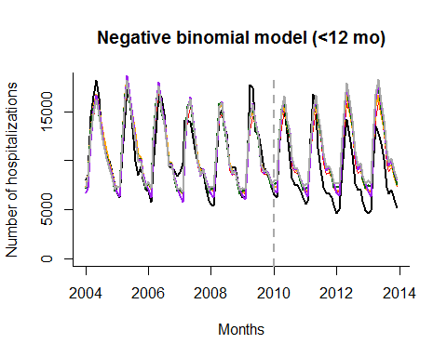

Calculate and plot RRs.

RR_lvso_yng <- young$J12_18/lvso_yng  
plot(RR_lvso_yng[,1] ~ young$date, type="l", bty="l", col="red",  
 main="RR for <12 mo", xlab="Months", ylab="Estimated RR", ylim=c(0.5,1.5))  
for (i in 2:6) {  
 lines(RR_lvso_yng[,i] ~ date, data=young, col=col[i],lwd=2)  
}  
abline(h=1,col="darkgrey",lty=2)  
abline(v=as.Date("2010-01-01"),col="darkgrey",lty=2)

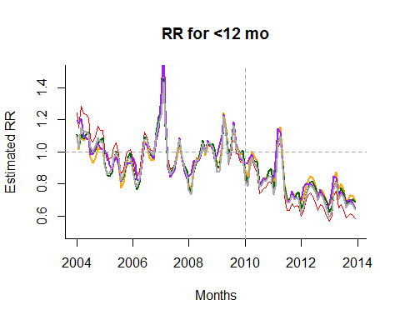

## Part 3. Interrupted Time Series Analysis

In this section, we compare a simple univariate linear regression with interupted time series regressions where we test whether the slope of the line changes after vaccine introduction.

### Part 3-a. Set up

First, let's create the following dummy variables for the post-vaccine period. * period1: 1 if 1-12 months after PCV10 introduction * period2: 1 if >12 months after PCV10 introduction

# <12 mo  
young$period1 <- 0  
young$period2 <- 0  
young$period1[young$date>="2010-01-01" & young$date<"2011-01-01"] <- 1  
young$period2[young$date>="2011-01-01"] <- 1  
# 80+ yo  
old$period1 <- 0  
old$period2 <- 0  
old$period1[old$date>="2010-01-01" & old$date<"2011-01-01"] <- 1  
old$period2[old$date>="2011-01-01"] <- 1

### Part 3-b. Fit 3 models

Fit an interrupted time series model as follows.

ITS_yng <- glm.nb(J12_18 ~ month + time*period1 + time*period2, data=young)  
ITS_old <- glm.nb(J12_18 ~ month + time*period1 + time*period2, data=old)

NOTE: This model includes time, period1, and period2 althouth these terms are not explicitly written in the code above.

### Part 3-c. Plot fitted values

Calculate fitted values.

Pred_ITS_yng <- predict(ITS_yng, newdata=young, type="response", se.fit=T)  
Pred_ITS_old <- predict(ITS_old, newdata=old, type="response", se.fit=T)

Make plots for the observed vs. fitted.

# <12 mo  
plot(Pred_ITS_yng$fit ~ young$date,  
 type="l",col="red", bty="l", lwd=2,  
 ylim=c(0,max(young$J12_18)),  
 ylab="Number of hospitalizations", xlab="Months",   
 main="Interrupted Time Series Model (<12 mo)")  
lines(J12_18 ~ date, data=young, col="black",lwd=2)  
abline(v=as.Date("2010-01-01"),col="darkgrey",lty=2, lwd=2)  
abline(v=as.Date("2011-01-01"),col="darkgrey",lty=2, lwd=2)  
legend("bottomleft", legend=c("Observed","ITS"),col=c("black","red"),lty=c(1,1),bty="n")

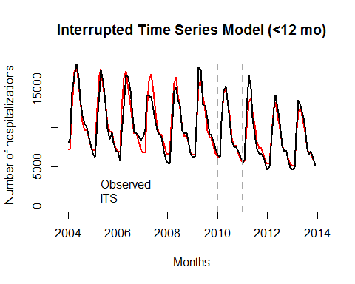

# 80+ yo  
plot(Pred_ITS_old$fit ~ young$date,  
 type="l",col="red", bty="l", lwd=2,  
 ylim=c(0,max(old$J12_18)),  
 ylab="Number of hospitalizations", xlab="Months",   
 main="Interrupted Time Series Model (80 yo)")  
lines(J12_18 ~ date, data=old, col="black",lwd=2)  
abline(v=as.Date("2010-01-01"),col="darkgrey",lty=2, lwd=2)  
abline(v=as.Date("2011-01-01"),col="darkgrey",lty=2, lwd=2)  
legend("bottomright", legend=c("Observed","ITS"),col=c("black","red"),lty=c(1,1),bty="n")

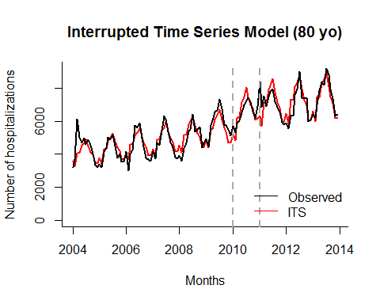

### Part 3-d. Generate counterfactual and estimate the impact of PCV10

Calculate the counterfactual which is the number of cases expected without PCV10. In this case, that's the following part of the model:

$$β_{0}+β_{1}*time+β_{2}*sin12+β_{3}*cos12$$

# < 12mo  
#cf_yng <-exp(ITS_yng$coef[1] + ITS_yng$coef[2]*young$sin12 + ITS_yng$coef[3]*young$cos12 + ITS_yng$coef[4]*young$time)  
cf_yng<- Pred_ITS_yng$fit / exp(young$period1*ITS_yng$coef['period1'] + young$period2*ITS_yng$coef['period2']   
 +young$period1*young$time*ITS_yng$coef['time:period1']   
 +young$period2*young$time*ITS_yng$coef['time:period2'] )  
# 80+ yo  
cf_old<- Pred_ITS_old$fit / exp(old$period1*ITS_old$coef['period1'] +old$period2*ITS_old$coef['period2']   
 +old$period1*old$time*ITS_old$coef['time:period1']   
 +old$period2*old$time*ITS_old$coef['time:period2'] )

Calculate and plot the number of cases averted.

# First, let's reformat ITS_###3$fit as follows:  
str(Pred_ITS_yng$fit) # It is a "named number", so let's unmane them

## Named num [1:120] 7226 7276 12810 17105 17945 ...  
## - attr(*, "names")= chr [1:120] "121" "122" "123" "124" ...

Pred_ITS_yng <- unname(Pred_ITS_yng$fit)  
Pred_ITS_old <- unname(Pred_ITS_old$fit)  
  
# Calculate the number of cases we averted using our intervention  
casesaverted_yng <- Pred_ITS_yng - cf_yng  
casesaverted_old <- Pred_ITS_old - cf_old  
  
# Plot  
plot(casesaverted_yng, col="orange", main="Cases averted, <12 mo", pch=16)  
abline(v=73, col="darkgrey", lty=2)  
abline(v=85, col="darkgrey", lty=2)

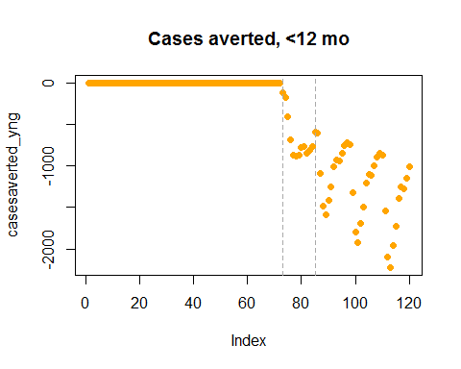

plot(casesaverted_old, col="orange", main="Cases averted, 80+ yo", pch=16)  
abline(v=73, col="darkgrey", lty=2)  
abline(v=85, col="darkgrey", lty=2)

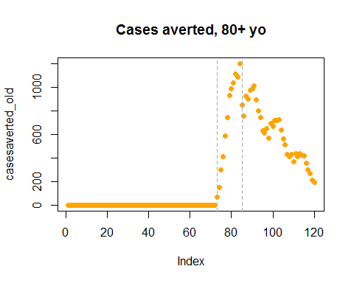

What about the change in rate?

# <12 mo  
RR_yng <- Pred_ITS_yng/cf_yng  
plot(RR_yng, type="l", col="blue", lwd=2, main="Rate ratio, <12 mo",  
 xlab="Months",ylab="Estimated RR", ylim=c(0.5, 1.5))  
abline(v=73, col="darkgrey", lty=2)  
abline(v=85, col="darkgrey", lty=2)  
abline(h=1, col='gray', lty=2)

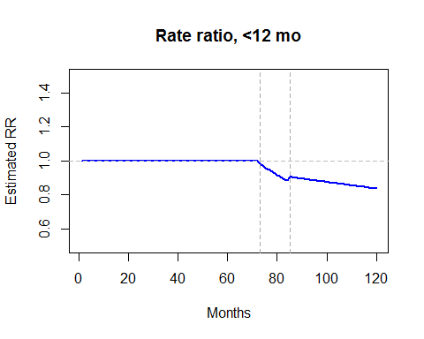

# 80+  
RR_old <- Pred_ITS_old/cf_old  
plot(RR_old, type="l", col="blue", lwd=2, main="Rate ratio, 80+ yo",  
 xlab="Months",ylab="Estimated RR", ylim=c(0.5, 1.5))  
abline(v=73, col="darkgrey", lty=2)  
abline(v=85, col="darkgrey", lty=2)  
abline(h=1, col='gray', lty=2)

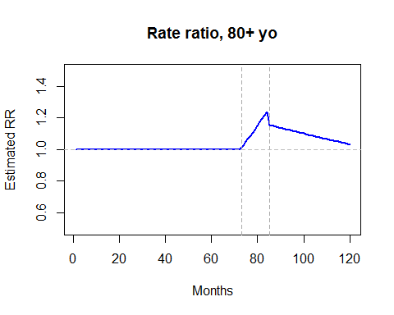

Thank you for your participation! Please feel free to contact us anytime if you have any questions! Daniel M. Weinberger ([daniel.weinberger@yale.edu](mailto:daniel.weinberger@yale.edu)) and Kayoko Shioda ([kayoko.shioda@yale.edu](mailto:kayoko.shioda@yale.edu))